Use Case Model

Use Case: BooksTeeTime

Brief Description: The purpose of this use case is to allow players, clerk or pro-shop staff of ClubBAISTGolfClubManagementSystem (GCMS) to book tee time.

Flow of Events

* Basic flow
* Use Case narrative

A GCMS player, clerk or pro-shop staff wants to book tee time

A GCMS player, clerk or pro-shop staff provides the following:

* Date

When completed, GCMS player, clerk or pro-shop staff submits the request to the system to view daily tee sheet. System processes the request and finds the tee sheet and returns tee sheet for that date to GCMS player, clerk or pro-shop staff. After looking at available tee times, GCMS player, clerk or pro-shop staff provides the following:

* Date
* Time
* NumberOfPlayers
* PlayerFirstName
* PlayerLastName
* PhoneNumber
* NumberOfCarts

After completing, GCMS player, clerk or pro-shop staff submits the request for book tee time to the system. System then processes the request and books tee time for the player and sends confirmation back to GCMS player, clerk or pro-shop staff.

* Primary scenario narrative

Primary Scenario: Justin Thomas, a Gold level player of GCMS, books tee time for Thursday June 25th, 2020 for 7 a.m. for himself. Justin Thomas provides the following:

* Date: June 25th, 2020

When completed, Justin submits the request to the system to view daily tee sheet. System processes the request and finds the tee sheet and returns tee sheet for June 25th, 2020 to Justin Thomas. After looking at available tee times, Justin Thomas provides the following:

* Date: June 25th, 2020
* Time: 7 a.m.
* NumberOfPlayers: 1
* PlayerFirstName: Justin
* PlayerLastName: Thomas
* PhoneNumber: 7808011114
* NumberOfCarts: 1

After completing, Justin Thomas submits the request for BooksTeeTime to the system. System then processes the request and books tee time for June 25th, 2020 at 7 a.m. and sends confirmation back to Justin Thomas.

* Alternative flows
  + Secondary/Alternate scenario narratives

Secondary Scenario: Ross Fisher, a Silver level player of GCMS, books tee time for Monday Feb 3rd, 2020 for 6 p.m. for himself. Ross Fisher provides the following:

* Date: Feb 3rd, 2020

When completed, Ross submits the request to the system to view daily tee sheet. System processes the request and finds the tee sheet and returns tee sheet for Feb 3rd, 2020 to Ross. After looking at available tee times, Ross provides the following:

* Date: Feb 3rd, 2020
* Time: 6 p.m.
* NumberOfPlayers: 1
* PlayerFirstName: Ross
* PlayerLastName: Fisher
* PhoneNumber: 7808231114
* NumberOfCarts: 1

After completing, Ross Fisher submits the request for BooksTeeTime to the system. System then processes the request and books tee time for Feb 3rd, 2020 at 6 p.m. and sends confirmation back to Ross Fisher.

Secondary Scenario: Lee Westwood, a Bronze level player of GCMS, books tee time for Wedneday Feb 5th , 2020 for 7 p.m. for himself. Lee Westwood provides the following:

* Date: Feb 5th , 2020

When completed, Lee submits the request to the system to view daily tee sheet. System processes the request and finds the tee sheet and returns tee sheet for Feb 5th , 2020 to Ross. After looking at available tee times, Lee provides the following:

* Date: Feb 5th , 2020
* Time: 7 p.m.
* NumberOfPlayers: 1
* PlayerFirstName: Lee
* PlayerLastName: Westwood
* PhoneNumber: 7808231151
* NumberOfCarts: 1

After completing, Lee Westwood submits the request for BooksTeeTime to the system. System then processes the request and books tee time for Feb 5th , 2020 at 7 p.m. and sends confirmation back to Lee Westwood.

Secondary Scenario: John Dhillon, a clerk of GCMS, books tee time for Friday Feb 7th , 2020 for 7 p.m. for Jack Allan (Silver-level player). John Dhillon provides the following:

* Date: Feb 7th , 2020

When completed, John Dhillon submits the request to the system to view daily tee sheet. System processes the request and finds the tee sheet and returns tee sheet for Feb 7th , 2020 to John Dhillon. After looking at available tee times, John Dhillon provides the following:

* Date: Feb 7th , 2020
* Time: 7 p.m.
* NumberOfPlayers: 1
* PlayerFirstName: Jack
* PlayerLastName: Allan
* PhoneNumber: 7808235551
* NumberOfCarts: 1

After completing, John Dhillon submits the request for BooksTeeTime to the system. System then processes the request and books tee time for Feb 7th , 2020 at 7 p.m. for Allan Jack and sends confirmation back to John Dhillon.

Secondary Scenario: Aman Gill, pro-shop staff of GCMS, books tee time for Monday Feb 10th , 2020 for 7 p.m. for Justin Thomas (Gold-level player). Aman Gill provides the following:

* Date: Feb 10th , 2020

When completed, Aman Gill submits the request to the system to view daily tee sheet. System processes the request and finds the tee sheet and returns tee sheet for Feb 10th , 2020 to Aman Gill. After looking at available tee times, Aman Gill provides the following:

* Date: Feb 10th , 2020
* Time: 7 p.m.
* NumberOfPlayers: 1
* PlayerFirstName: Justin
* PlayerLastName: Thomas
* PhoneNumber: 7808239051
* NumberOfCarts: 1

After completing, Aman Gill submits the request for BooksTeeTime to the system. System then processes the request and books tee time for Feb 10th , 2020 at 7 p.m. for Justin Thomas and sends confirmation back to Aman Gill.

* Special Requirements :N/A
* Preconditions :Tee sheet is required
* Postconditions : TeeTime was booked.
* Other diagrams :
* System Sequence Diagram (SSD)

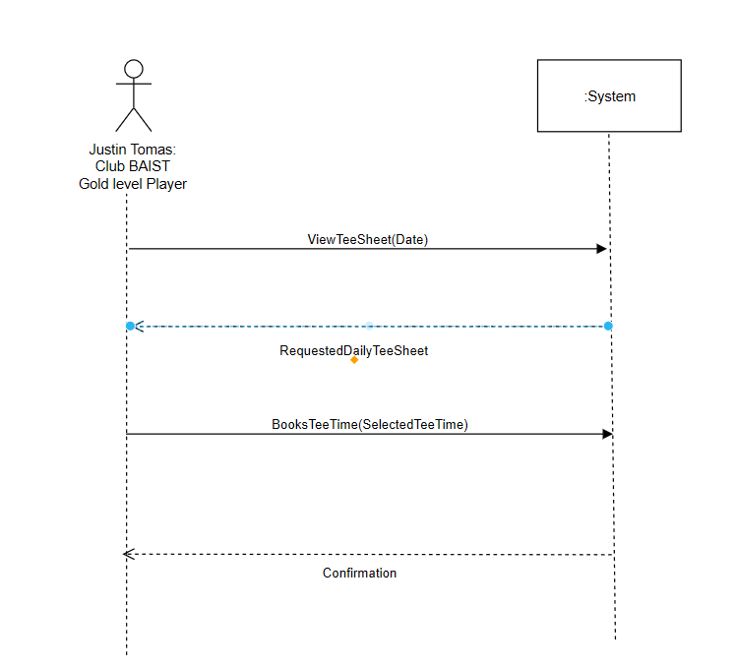

* User Interface Prototype

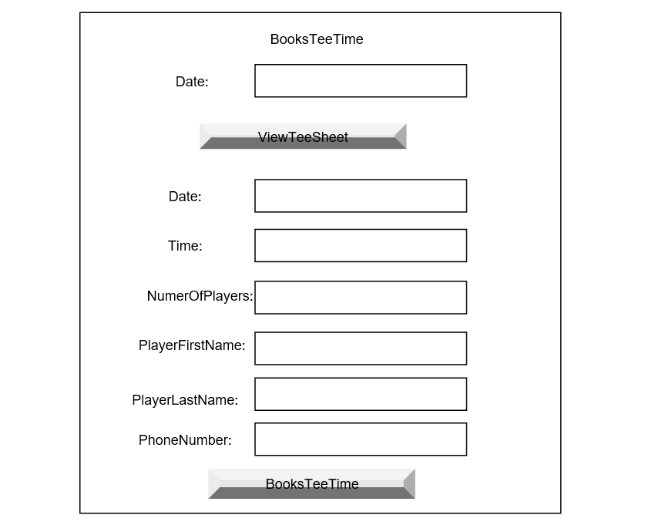

Use Case: ModifiesTeeTime

Brief Description: The purpose of this use case is to allow GCMS players, clerk and pro-shop staff of ClubBAISTGolfSystem to modify tee time.

Flow of Events

* Basic flow
* Use Case narrative

A ClubBAISTGolfSystem player, club or pro-shop staff wants to modify tee time

A GCMS player, clerk or pro-shop staff provides the following:

* Date
* Time

When completed, GCMS player, clerk or pro-shop staff submits the request to the system to View TeeTime for that provided date and time. System processes the request and finds the tee time and returns it for that date and time to GCMS player, clerk or pro-shop staff.

After looking at previously booked tee times, GCMS player, clerk or pro-shop staff provides the following:

* Date
* Time
* NumberOfPlayers
* PlayerFirstName
* PlayerLastName
* PhoneNumber
* NumberOfCarts

After completing, GCMS player , clerk or pro-shop staff submits the request ModifiesTeeTime to the system. System then processes the request and ModifiesTeeTime for the player and sends confirmation back to GCMS player, clerk or pro-shop staff.

* Primary scenario narrative

Primary Scenario: Justin Thomas, a Gold level player of GCMS, wants to ModifiesTeeTime to change his PlayerLastName to Mahi.

So Justin provides the following:

* Date: June 25th, 2020
* Time: 7 a.m.

When completed, Justin submits the request to the system for ViewTeeTime. System processes the request and gets the booked TeeTime information for June 25th, 2020, 7 a.m. After looking at his booked tee time information, Justin then provides the following:

* Date: June 25th, 2020
* Time: 7 a.m.
* NumberOfPlayers: 1
* PlayerFirstName: Justin
* PlayerLastName: Mahi
* PhoneNumber: 7808011114
* NumberOfCarts: 0

After completing, Justin Thomas submits the request ModifiesTeeTime to modify his TeeTime information to the system for himself. System then processes the request and modifies his tee time 9 p.m information and sends confirmation back to Justin Thomas.

* Alternative flows

Secondary scenario narratives

Secondary Scenario: Rahul Sharma, clerk of GCMS, wants to Modify TeeTime information to change PlayerFirstName of Justin Thomas to John, whose TeeTime is booked for Thursday June 25th, 2020 for 7 a.m

Rahul Sharma provides the following:

* Date: June 25th, 2020
* Time: 7 a.m.

When completed, Rahul submits the request to the system to view TeeTime for Date June 25, 2020 at 7 a.m. System processes the request and finds the booked tee time information for June 25th 2020 at 7 a.m. and returns it to Rahul Sharma.

After looking at booked tee time of Justin, Rahul then provides the following:

* Date: June 25h, 2020
* Time: 7 a.m.
* NumberOfPlayers: 1
* PlayerFirstName: John
* PlayerLastName: Thomas
* PhoneNumber: 7808021114
* NumberOfCarts: 1

After completing, Rahul Sharma submits the request ModifiesTeeTime to the system. System then processes the request and modifies tee information i.e. FirstName of Justin Thomas John and sends confirmation back to Rahul Sharma.

Secondary Scenario: Deep Brar, pro-shop staff of GCMS, wants to Modify TeeTime to change booked tee time information for David Toms which is Thursday February 13th, 2020 for 7 a.m. to change his check-in time.

Rahul Sharma provides the following:

* Date: February 13th, 2020
* Time: 7 a.m.

When completed, Deep submits the request to the system to ViewTeeTime for Date February 13th, 2020 at 7 a.m. System processes the request and finds the booked tee time for February 13th, 2020 at 7 a.m. and returns it to Deep.

After looking at booked tee time information of David, Deep then provides the following:

* Date: February 14th, 2020
* Time: 7:30 a.m.
* NumberOfPlayers: 1
* PlayerFirstName: David
* PlayerLastName: Toms
* PhoneNumber: 7808011789
* NumberOfCarts: 1

After completing, Deep submits the request ModifiesTeeTime to the system. System then processes the request and modifies tee time information for David Toms and sends confirmation back to Deep.

Secondary Scenario: Deep Brar, pro-shop staff of GCMS, wants to Modify TeeTime to change booked tee time information for David Toms to change his contact information whose TeeTime is booked for Thursday February 13th, 2020 for 7 a.m.

Deep Brar provides the following:

* Date: February 13th, 2020
* Time: 7 a.m.

When completed, Deep submits the request to the system to ViewTeeTime for Date February 13th, 2020 at 7 a.m. System processes the request and finds the booked tee time information for February 13th, 2020 at 7 a.m. and returns it to Deep.

After looking at booked tee time information of David, Deep then provides the following:

* Date: February 14th, 2020
* Time: 7:30 a.m.
* NumberOfPlayers: 1
* PlayerFirstName: David
* PlayerLastName: Toms
* PhoneNumber: 7808011678
* NumberOfCarts: 1

After completing, Deep submits the request ModifiesTeeTime to the system. System then processes the request and modifies tee time information for David Toms and sends confirmation back to Deep.

Use Case: MakesStandingTeeTimeRequest

Brief Description: The purpose of this use case is to allow shareholder members of GCMS to make standing tee time request.

Flow of Events

* Basic flow
* Use Case narrative

A shareholder member of GCMS wants to make standing tee time request

A shareholder member of GCMS provides the following:

* Date

When completed, shareholder member submits the request to the system to View Standing TeeTimes by submittind ViewStandingTeeTimeRequest. System processes the request and finds standing tee times and returns standing tee times for that date to shareholder member. After looking at available standing tee times, shareholder member provides the following:

* MemberNumber
* MemberFirstName
* MemberLastName
* RequestedTime
* RequestedStartDate
* RequestedEndDate

After completing, shareholder member submits the MakesStandingTeeTimeRequest to book standing tee time to the system. System then processes the request and books standing tee time and sends confirmation back to shareholder member.

* Primary scenario narrative

Primary Scenario: David Toms MakesStandingTeeTime request for June 5th, 2020, Monday for 11 a.m. for himself.

Scenario: David Toms, a shareholder member of GCMS wants to make one standing tee time request. For this, David Toms wants to view standing tee times. So, David Toms provides the following:

* Date: June 5th, 2020

When completed, David submits the request to the system to View Standing TeeTimes by submitting ViewStandingTeeTimeRequest. System processes the request and finds standing tee times and returns standing tee times for June 5th, 2020 to David Toms. After looking at available standing tee times, David Toms provides the following:

* MemberNumber: 11231
* MemberFirstName: David
* MemberLastName: Toms
* RequestedTime: 11 a.m.
* RequestedStartDate: June 5th, 2020
* RequestedEndDate: June5th, 2020

After completing, David Toms submits the MakesStandingTeeTimeRequest to the system. System then processes the request and books standing tee time for June 5th, 2020, 11 a.m. and sends confirmation back to David Toms.

Alternative flows : N/A

Special Requirements :N/A

Preconditions : List of previously requested standing tee times .

Postconditions : Standing Tee time request was submitted.

Use Case: CancelStandingTeeTimeRequest

Brief Description: The purpose of this use case is to allow shareholder members of GCMS to cancel standing tee time request.

Flow of Events

* Basic flow
* Use Case narrative

A shareholder member of GCMS wants to cancel standing tee time request

A shareholder member of GCMS provides the following:

* Date

When completed, shareholder member submits the request to the system to view standing tee times by submitting View standing tee time request. System processes the request and finds standing tee times and returns standing tee times for that date to shareholder member. After looking at a requested standing tee times, shareholder member provides the following:

* RequestedTime
* RequestedStartDate
* RequestedEndDate

After completing, shareholder member submits the CancelsStandingTeeTimeRequest to the system. System then processes the request and cancels standing tee time and sends confirmation back to shareholder member.

* Primary scenario narrative

Primary Scenario: Buddy Allin, Shareholder member makes CancelsStandingTeeTimeRequest for June 5th, 2020, Monday for 11 a.m. for himself.

Scenario: Buddy Allin, a shareholder member of GCMS wants to make CancelsStandingTeeTimeRequest. For this, Buddy Allin wants to view his standing tee time. So, Buddy Allin provides the following:

* Date: June 5th, 2020
* Time: 11 a.m.

When completed, Buddy Allin submits the request to the system to view standing tee times by submittind ViewStandingTeeTimeRequests. System processes the request and finds standing tee times and returns standing tee times for June 5th, 2020 to Buddy Allin. After looking at standing tee time requests, Buddy Allin provides the following:

* RequestedTime: 11 a.m.
* RequestedStartDate: June 5th, 2020

After completing, Buddy Allin submits the CancelsStandingTeeTimeRequest to the system. System then processes the request and cancels standing tee time for June 5th, 2020, 11 a.m. and sends confirmation back to Buddy Allin.

Alternative flows : N/A

Special Requirements :N/A

Preconditions : List of previously requested standing tee time .

Postconditions : StandingTeeTimeRequest cancelled.